|  |  |
| --- | --- |
| Safety Backup System | |
|  |
| Beta Version  Nicholas Marasco |

# Introduction

|  |
| --- |
| This software is created to safely backup all data on your computer to a device or a server. The scope is to prevent any data losses caused by machine damage and virus attack. |
|  |

# Setup Server Info

# To make the software works you need to specify the URL where the client will take necessary info to communicate with the server, the URL is provided by the Software Administrator.

# Click on “Server Info”:

1. Enter the URL provided and Save: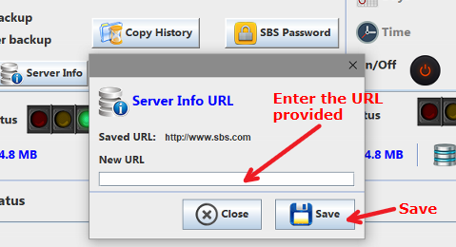

# Enter user Info

Since this software has an annual license, the server needs to recognize every user, so you need to enter the user info provided.

1. Click on “User Info”

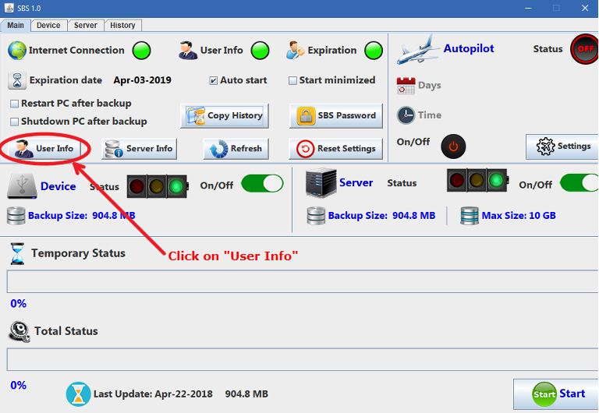

1. Enter User info provided:

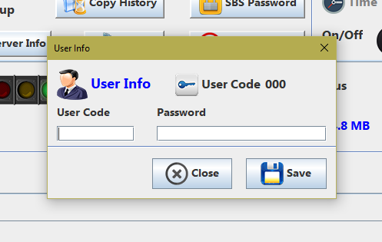

# Device Backup

SBS allows you to backup your data on a device.

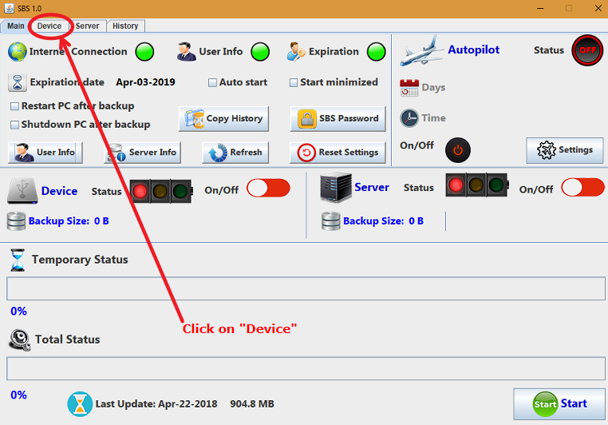

Once you are in the device panel you can start to manage the dedicated settings

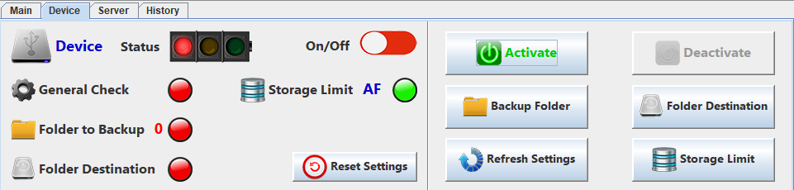

In the left panel you have a check panel that shows you the status of device settings, in the right panel you have the options to manage them.

Choose folders to backup:

To choose what folder SBS will backup you must click to “Backup Folder” button:

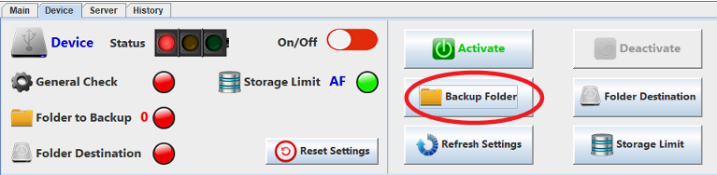

And a window will show up:

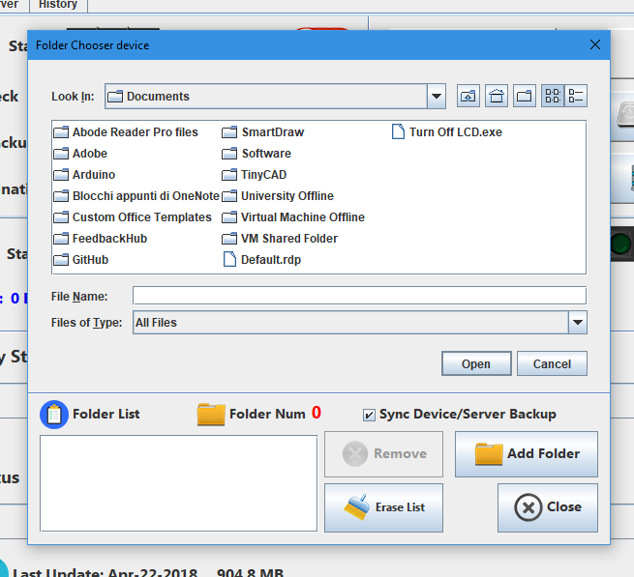

Here you can add folder to the list, remove a folder from list selecting it and clicking on *remove* or you can erase all list.

Sync Device/Server Backup feature:

This feature allows you to have the same backup in device and in the server, this means a remarkable time saving in case of both backup type are activated. This because SBS will use the file previously copied in SBS temporary folder for both backup. Anyway, if you need to backup different folder in device and server you can uncheck the option and choose separately the folders for device and for the server.

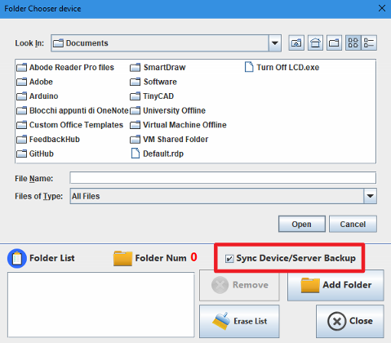

Folder Destination:

The *device backup* requires a folder destination, you can choose it clicking on “Folder Destination” button on the right panel.

Storage Limit:

With this option you can choose if SBS will automatically delete old backups in the folder if the sum of all backups exceeds the limit chosen. You can also choose to automatically delete old backup if the device memory is too low.

Otherwise you can turn off all the limit and manage the device storage manually.

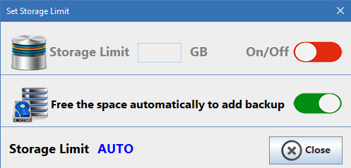

# Server Backup

SBS allows you to backup your data on our server.

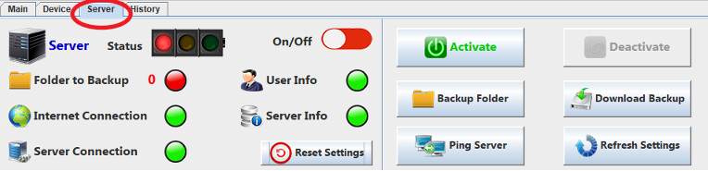

Setting up the Folder to backup is identical to Device backup.

Download Backup

To download the previous backups, you must click on “*Download Backup*”.

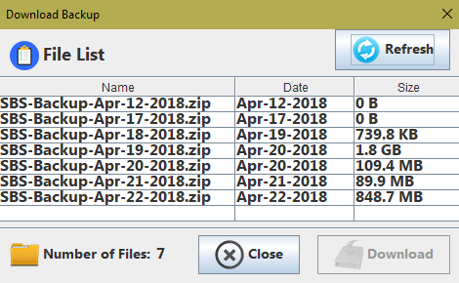

By clicking Refresh you will get the list of your backup that are in SBS server. To download one, you must click on the backup, and click “*Download*”.

# Backup Type

Once you had managed Device and Server settings and you got the

*green light*, you can activate one or both of them. In Backup Control Panel you have a summary of the backup status, you can check the size of your backup and the max size allowed in server backup.

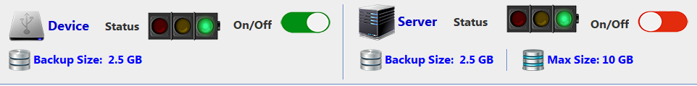

# History

By clicking on “*history*” you can check all the backups done. It’s necessary to click *refresh* to show them.

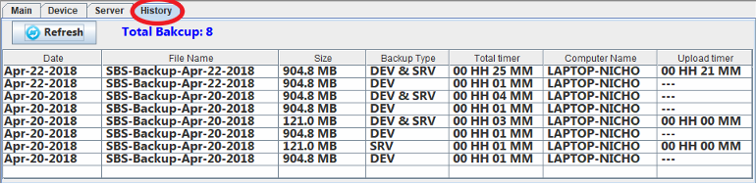

# Main Settings

In *Main Settings* panel you can manage the settings of SBS.

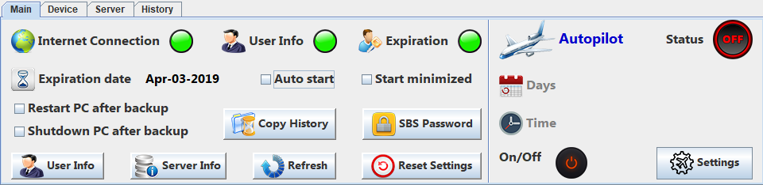

Autopilot

The autopilot is a feature that allows you to schedule the backup.

To turn it on you must click on “*on/off*” icon.

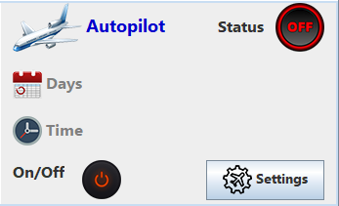

By clicking on *Settings,* you can set days and hours.

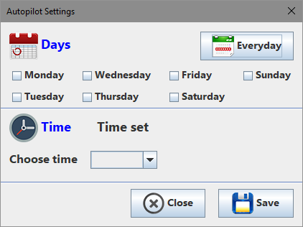

Autostart

Autostart allows you to decide if SBS will start automatically at user login.

Start minimized

Start minimized allows you to decide if SBS will start minimized in system tray.

Restart/Shutdown PC after backup

Allows you to decide if SBS will restart/shutdown PC when completes the backup.

SBS Password

SBS Password allows you to prevent that other users modify backup settings.

Copy History

“Copy History” creates a file of all backups history (the same of *history* section) to a folder chosen by the user.

